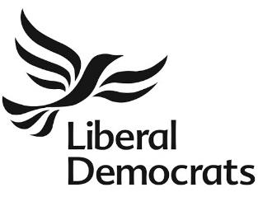 North Cotswolds & Tewkesbury Liberal Democrats
Nomination for Executive Committee
Name of Candidate:
Membership number:
Position applied for:
For Which Party (circle those you are willing to accept the role for):
North Cotswold & Tewkesbury North Cotswold Tewkesbury
Your Address
Phone:
Email address:
I agree to be nominated for the above post:
................................................................................................. (Signature of candidate)
Nominated by
Candidates must be proposed and seconded by any two current members of the North Cotswolds & Tewkesbury Liberal Democrats:
Proposer:
.................................................................................. (Name in block capitals)
.................................................................................. (Signature of Proposer)
Seconder:
.................................................................................. (Name in block capitals)
.................................................................................. (Signature of Seconder)
PLEASE SCAN OR TAKE A PICTURE OF THIS FORM ON YOUR PHONE AND EMAIL TO Kate Usmar (Party secretary): Katherine.Usmar@outlook.com BY 21st NOVEMBER 2025.

