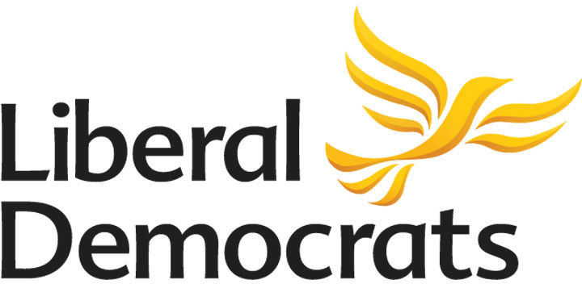
ANNUAL GENERAL MEETING
NORTH COTSWOLDS & TEWKESBURY LIBERAL DEMOCRATS
7.00pm, Monday 24th November 2025
CCA, Churchdown
AGENDA
- Welcome & Apologies

- Chair’s Report

- To discuss and vote on the proposal to form 2 separate Constituency Parties

- Election of Party Officers & Executive Committee for 2025:
- Chair - Vice Chair
- Secretary - Treasurer
- Data Officer - Membership Development Officer
- Diversity Officer - Communications Officer
- Fundraising & Events Officer
- Ordinary Members x 4
- Report from the Autumn Party Conference

- Any Other Business

